**Computational Biology Group Exercise**

**Group Number: 911**

**Introduction**

Glycolysis is the first metabolic pathway that generates energy in the form of adenosine triphosphate (ATP) to support the daily basis of an organism. This pathway is anaerobic and occurs in the cytosol of eukaryotic cells (Alberts et al., 2015). Glycolysis functions by sequentially breaking down one molecule of six-carbon glucose into two molecules of pyruvate within 10 different enzymatic reactions (Berg et al., 2002; Li et al., 2015). This stepwise breakdown of glucose prevents energy waste and utilise glucose to the utmost (Alberts at al., 2015). Pyruvate is a three-carbon molecule that enters the Krebs cycle to generate more ATP and continues the next step of cellular respiration. At the end of glycolysis, a net gain of 2 molecules of ATP and 2 activated electron carrier NADH are produced (Campbell et al., 2018; Alberts et al., 2015; Guo et al., 2012).

Glycolysis involves two different phases, which are the energy investment phase and the energy pay-off phase. In the former phase, 2 molecules of ATP are invested to drive glycolysis, while at the energy pay-off phase, 4 molecules of ATP are generated. As a result, a net gain of 2 ATPs is produced by substrate-level phosphorylation at the end of glycolysis (Campbell et al., 2018; Alberts et al., 2015). On the other hand, the glycolytic pathway also produces various kinds of important biomolecules. Some intermediate molecules of glycolysis are key precursors of other more complex metabolic pathways. For example, the first intermediate molecule of glycolysis, glucose 6-phosphate, can be involved both in nucleotide synthesis and glycogen synthesis (Li et al., 2015).

This report describes our work done to an incomplete glycolysis model. Our team not only have corrected and extended the original model, but also have conducted an additional *in-silico* experiment to the model. We imitated the real-life situation of a human body by inserting the Cori Cycle into the model. We explored the mechanism of glycolysis and have linked this crucial pathway to other important biological reactions. This project has allowed our team to learn and consolidate the mechanism of glycolysis, relating knowledge of biochemistry while improving our skills on using the COPASI software.

**Base model**

We used a model containing steps 1-6 of glycolysis provided by the instructor. The following steps were taken to check the quality of the model and identify the mistakes:

1. Before we ran the model, we had checked the reaction steps. The first mistake we found was the lack of ATP in step 3. Because if ADP exists as a product in a chemical reaction, the reaction must have ATP as one of its reactants. Therefore, we added an ATP molecule in step 3.
2. The second mistake we found was in step 4, in which aldose only appeared as products. As an enzyme, it should occur in both the reactants and the products. Thus, we added aldose to the reactants to define it as an enzyme in the reaction.
3. After we got the plot, we found that the initial concentration of NAD+ is 0 mmol/ml, which is impossible in the human body. Therefore, we changed the concentration of NAD+ from 0 mmol/ml to 2 mmol/ml to make it more realistic. This also allowed step 6 of the glycolysis model to proceed by providing NAD+ to the reaction.
4. Finally, we found a strange substance called ructose_6_phosphate in step 2. After looking up its definition, it turned out that ructose_6_phosphate and fructose_6_phosphate were the same substances (Alberts et al., 2015). We also noticed that fructose_6_phosphate appeared in step 3 and 4 instead of ructose_6_phosphate. Therefore, we thought that in step 2, it should be fructose_6_phosphate. We changed ructose_6_phosphate to fructose_6_phosphate and removed the ructose_6_phosphate from “Species”.

**Extension of the model**

In the first six steps, we obtained 1_3_bisphosphoglycerate. Hence, our next goal was to complete the glycolysis model by converting 1_3_bisphosphoglycerate to pyruvate within four steps.

**Step 7: 1_3_bisphosphoglycerate + phosphoglycerate_kinase + ADP = 3_phosphoglycerate + ATP + phosphoglycerate_kinase (Alberts et al., 2015; Campbell et al., 2018)**

First, we constructed a reversible reaction that converts 1_3_bisphosphoglycerate to 3_phosphoglycerate, which consumes energy and requires an enzyme to catalyse it. Therefore, ADP and a special enzyme called phosphoglycerate kinase were added to the reactants. Accordingly, the products contain ATP and phosphoglycerate kinase. In addition, we added phosphoglycerate kinase and 3_phosphoglycerate to “Species”. We set the initial concentrations of 3_phosphoglycerate as 0 mmol/ml and phosphoglycerate kinase as 1 mmol/ml.

**Step 8: 3_phosphoglycerate + phosphoglycerate_mutase = 2_phosphoglycerate + phosphoglycerate_mutase (Alberts et al., 2015; Campbell et al., 2018)**

The next step was to convert 3_phosphoglycerate to 2_phosphoglycerate, which is catalysed by an enzyme named phosphoglycerate mutase. Therefore, we added phosphoglycerate mutase in the reactants, products and “Species”. We set its initial concentration as 1 mmol/ml, as well as adding 2_phosphoglycerate in “Species” and setting its initial concentration as 0 mmol/ml. This reaction was set to be a reversible reaction.

**Step 9: 2_phosphoglycerate + phosphopyruvate_hydratase = phosphoenolpyruvate + phosphopyruvate_hydratase (Alberts et al., 2015; Campbell et al., 2018)**

After obtaining 2_phosphoglycerate, we used phosphopyruvate hydratase to translate 2_phosphoglycerate to phosphoenolpyruvate through a reversible reaction. Similar to step 7 and 8, phosphoenolpyruvate and phosphopyruvate hydratase were added to “Species” and their initial concentrations were set respectively as 0 mmol/ml and 1mmol/ml. In such an aqueous environment as cytosol, water production of this reaction should not affect the reaction rate, therefore, water is excluded from the equation above.

**Step 10: phosphoenolpyruvate + ADP + pyruvate_kinase -> pyruvate + ATP + pyruvate_kinase (Alberts et al., 2015;** **Campbell et al., 2018)**

The last step was to obtain pyruvate. This is an exergonic and irreversible reaction catalyzed by pyruvate kinase. We used phosphoenolpyruvate and ADP as the reactants while pyruvate and ATP as the products. Pyruvate kinase was added to “Species” and its initial concentration was set as 1 mmol/ml. Pyruvate was also written into “Species” with an initial concentration of 0 mmol/ml because it was the final product of glycolysis.

**Simulations**

**Stochiometry**

Yes. Glycolysis produces two molecules of pyruvate for every molecule of glucose used. This process is reflected in our model through the following aspects:

1) In the overall reaction equation of glycolysis, that is, c6h12o6-> 2C3H4O3+4[H], one molecule of glucose corresponds to two molecules of pyruvate according to the conservation of carbon.

2) In step 4, one molecule of fructose-1,6-bisphosphate (6 Carbon) turns into one molecule of dihydroxyacetone-phosphate (3 Carbon) and one molecule of glyceraldehyde-3-phosphate (3 Carbon). In step 5, dihydroxyacetone-phosphate (3 Carbon) becomes one molecule of glyceraldehyde-3-phosphate. In the following steps, glyceraldehyde-3-phosphate is transformed into pyruvate. It means that one glucose molecule produces two molecules of glyceraldehyde-3-phosphate, subsequently into two molecules of pyruvate.

3) To make the result more obvious, we plotted the concentration change of glucose and pyruvate over time. As shown in **Fig. 1**. The initial concentration of glucose is 1mmol/ml and the initial concentration of pyruvate is 0mmol/ml. During reaction, when [glucose] tends to 0 mmol/ml, [pyruvate] tends to 2 mmol/ml. But, since glycolysis involves 10 steps and most of the reactions are reversible, the concentration ratio of glucose to pyruvate at the end of glycolysis is only approximate to 1:2. This explains why the concentration of pyruvate at the end of glycolysis shown in Figure 1 does not reach 2 mmol/ml sharply. However, this difference is so small that it can be neglected.

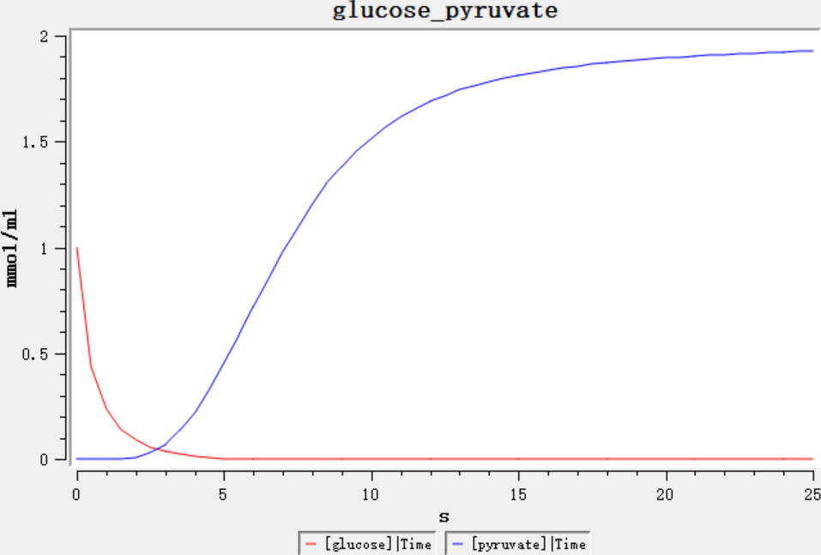**ATP production**

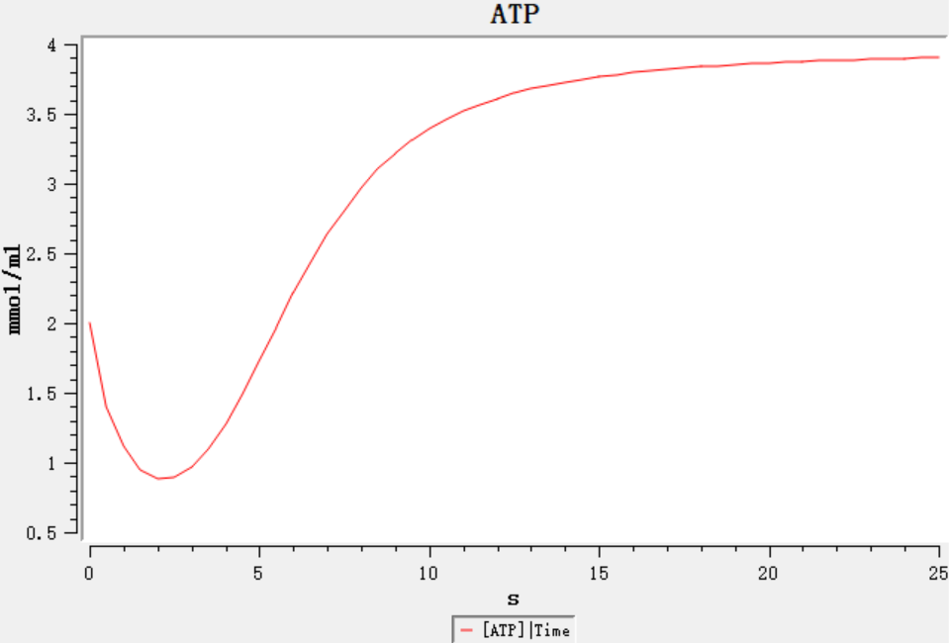Yes. The initial concentration of ATP is 2mmol/ml, but as the reaction goes on, it first drops to about 0.8 mmol/ml, then rises and tends to 4 mmol/ml (**Fig. 2)**. The reason for this change in concentration is that the reaction is reversible. In the early stage, the rate of ATP generation is less than that of consumption. When the reaction lasts for about 2.2 minutes, it reaches dynamic equilibrium and the concentration of ATP is the lowest. In the later stage of the reaction, the formation rate of ATP is high while the consumption rate is low. Hence, the concentration increases and tends to be 4 mmol/ml.

**Fig. 1** Concentration changes of glucose and pyruvate over time.

**Triose phosphate isomerase mutation**

The catalyst affects the rate of the reaction. We changed the initial concentration of enzyme to simulate the enzyme deletion caused by the gene mutation. Then, we analysed the reaction results through data plotting. As shown in Figure 3, with the initial concentration of triose phosphate isomerase as the x-axis and the final concentration of pyruvate as y-axis, we used parameter scan in COPASI and plotted **Fig. 3.**

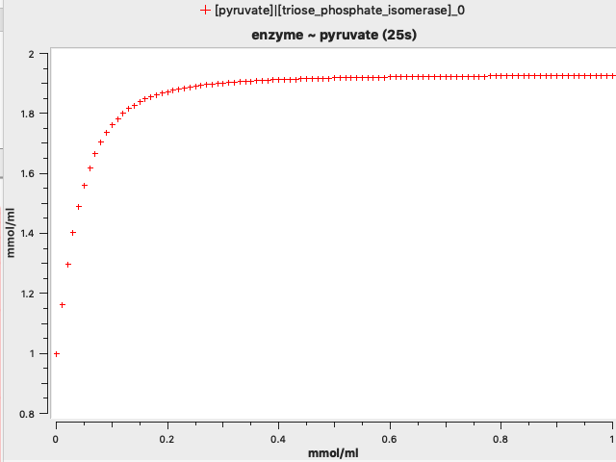From **Fig. 3**, it can be concluded that the higher the initial concentration of the enzyme is, the higher final concentration of pyruvate will be. The trend is particularly obvious in the interval of 0-0.2mmol/ml. When the initial concentration of enzyme is higher than 0.2 mmol/ml, which means the enzyme is sufficient, the increase is not obvious, and the pyruvate concentration tends to 2 mmol/ml. For a single reaction, the enzyme only influences the reaction rate. Nevertheless, glycolysis involves 10 sub-steps, so a change in the rate of step 5 can cause a chain reaction. The accumulation of intermediate products leads to some unresponsive steps. For example, due to the enzyme mutation, the slower formation rate of glyceraldehyde_3_phosphate will lead to the slower rate of step 6. Thus, through the chain reactions, the final yield of pyruvate will be different.

**Fig. 2** Concentration change of ATP over time.

**Fig. 3** The concentration of pyruvate varies with the initial concentration of triose phosphate isomerase.

**Additional *in silico* experiment**

**Introduction to the Cori cycle**

At rest, oxygen is sufficient in muscle cells to carry out electron transport chain, leading to enough NAD+ back in Krebs cycle. Due to the Le Chatelier's principle, the increase in reactants will promote the reaction. Thus, pyruvate is mainly driven into the Krebs cycle instead of producing lactic acid. During strenuous exercises, however, the lack of oxygen arouses anaerobic metabolism. Oxidative phosphorylation stops without oxygen so that decreased NAD+ suppresses the entry of pyruvate into Krebs cycle but accelerates lactic acid production. The sharp increase of lactic acid may arouse muscle fatigue and acute muscle soreness, especially in lactate dehydrogenase-mutated individuals (Yuan and Braun, 2017). Moreover, tumours rely on more lactic acid than mitochondrial respiration, which is a phenomenon named Warburg effect (Liberti and Locasale, 2016).

To deal with the excess lactic acid in cells, a metabolic pathway named Cori cycle takes place. Lactic acid in muscle cells travels to liver cells (hepatocytes) where it is converted into pyruvate by lactic dehydrogenases. Pyruvate undergoes gluconeogenesis and becomes glucose, which is then, transferred backwards to muscle cells through the bloodstream **(Fig. 4).**

**Fig. 4 Gluconeogenesis pathway** (**A**, adapted from Miyamoto and Amrein, 2017) and the **Cori cycle** (**B**, Numbers in the Cori circle are the same as the reaction order of in-silico set up). See text for details.

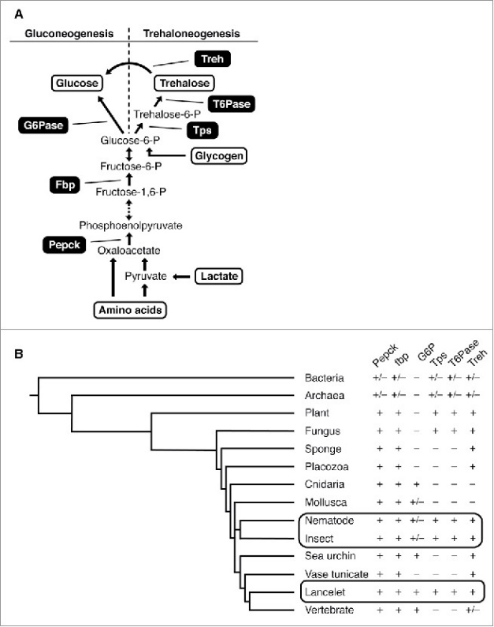

B



Hepatocytes

Muscle cells

Moreover, the Cori cycle is an important pathway of gluconeogenesis against hunger. At rest, the body still produces lactate. The possible origins of lactate are red blood cells without mitochondria, skin and other tissues which have strong glycolysis. Even in muscles, there can be a small amount of lactate generation. According to Katz and Tayek (1998), after 12 hours, 20 hours and 40 hours of fasting, the proportion of gluconeogenesis is 41%, 71%, and 92% respectively, while Cori cycle lactate contributes 18%, 35%, and 36% to gluconeogenesis.

Interestingly, Cori cycle consumes ATP. 4 molecules of ATP and 2 molecules of GTP are required to convert 2 pyruvate molecules into 1 glucose-6-phosphate, but glycolysis only provides 2 ATP. It is considered that the energy burden is moved from the muscle to the liver.

In the following additional *in-silico* experiment, we modelled the Cori cycle in COPASI to explore the concentration change of glucose, pyruvate, lactic acid and ATP which outline cellular respiration.

The **hypothesis** made is that during intense exercising, more lactic acid will be produced in muscle cells due to the lack of oxygen, which will finally be converted into glucose to maintain ATP synthesis through glycolysis.

**Respiration and the Cori cycle *in-silico* setup**

Two compartments including skeletal muscle cells and hepatocytes were made. Species belong to hepatocytes were denoted by the prefix “h_”. According to the principles of Cori cycle, 6 reactions were added:

1. **pyruvate + NADH + lactate_dehydrogenase = lactic_acid + NAD + lactate_dehydrogenase**

(Lactic acid genesis from pyruvate in skeletal muscle cells)

1. **lactic_acid -> h_lactic_acid**

(Transportation of lactic acid from skeletal muscle cells to hepatocytes)

1. **h_lactic_acid + h_NAD + h_lactate_dehydrogenase = h_lactate_dehydrogenase + h_NADH + h_pyruvate**

(Pyruvate regeneration from lactic acid with the same enzyme but in different compartments)

1. **2 * h_pyruvate + 6 * h_ATP + 2 * NADH = h_glucose + 2 * NAD**

(Gluconeogenesis in hepatocytes)

1. **h_glucose -> r_glucose**

(Transportation of glucose from hepatocytes to skeletal muscle cells. Since we focused on the amount of glucose of the first circulation of Cori cycle, glucose returned to skeletal muscle cells is denoted as r_glucose.)

1. **pyruvate + 3 oxygen -> 15 * ATP**

(consumed pyruvate in skeletal muscle through aerobic respiration, CO2 & H2O product is neglectable in this experiment thus excluded in this reaction)

For the reversible reactions 3 & 4, the kinetics were set to 1 for the forward rate constant and 0.01 for backward constant. For reaction 2 & 5 which represent substances transfer via the circulatory system, change of the rate constant (k2, k5) can be used to mimic the impact of the exo/endocytosis process as well as transportation process of glucose. The ratio of aerobic respiration rate constant (k6) and kf of reaction 1 (kf1) displays the relative prevalence between anaerobic and aerobic respiration under different circumstances, which was tested in this experiment. To keep the equilibrium constant unchanged, kb1 was assigned to be kf1/100.

**At rest**

Respiration reactions were first restricted in muscle cells and no Cori cycle took place. k6 was set to 1 while kf1 was 0.1 so as to represent the prevailing aerobic respiration. The result in **Fig. 5**. showed that 6 units of oxygen were converted to the net gain of 30 ATP in aerobic respiration with little lactic acid produced. The average reaction rate of ATP synthesis is 275 times faster than lactic acid production within 30 seconds.

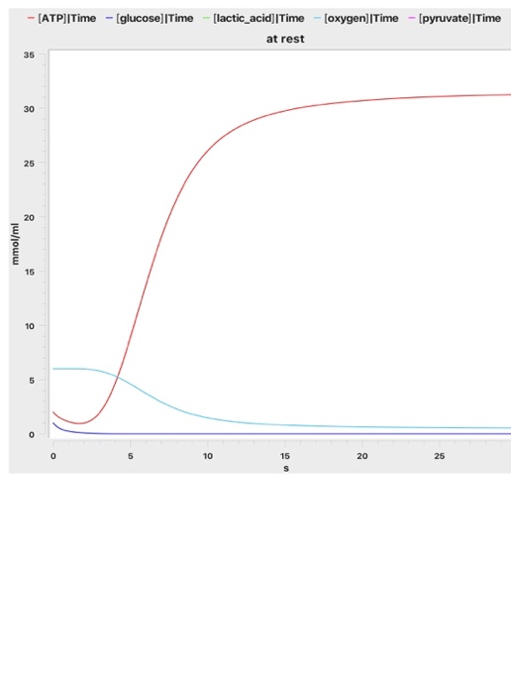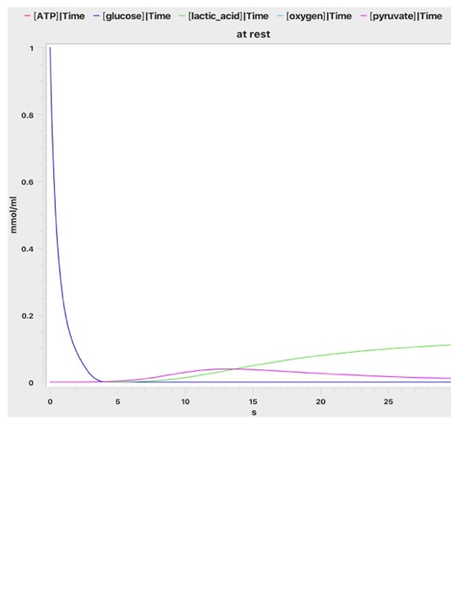

**Fig. 5 Predominant aerobic respiration at rest.** Around 30 ATP were produced at the cost of 6 oxygen molecules (red curve). Only small amount of pyruvate underwent anaerobic respiration, producing little lactic acid (violet curve).

**Hypoxia during exercising**

While doing exercises, oxygen supply is low in muscle cells (hypoxia), so the amount of pyruvate that undergoes aerobic respiration via the Krebs cycle is reduced (Hochachka and Mommsen, 1983). To provide enough energy, more NAD+ are used to produce ATP in glycolysis. In order to restore NAD+ without oxygen involved, lactic acid genesis is promoted. The subsequent retention of lactic acid in muscles may cause painful lactic acidosis (Robergs *et al.*, 2004). To present the above process, the oxygen initial level was scanned from 0 to 6 over 30 seconds. Other settings remained the same as resting situation. 30 seconds was long enough for lactic acid formation to reach a plateau (**Fig. 6**). Less oxygen supply increases lactic acid production and decreases ATP synthesis. Since the production speed of lactic acid is also elevated during intense exercise, kf1 was then scanned from 0.1 to 10 and showed a plateau of lactic acid production at 1.79.

**Fig. 6** **Hypoxia-related parameters during exercising.** **a**. Plateau of lactic acid production was found around 30s (no oxygen). **b**. deficiency of oxygen promoted lactic acid production and restricted ATP production. **c**. forward rate constant of lactic acid production (kf1) was related with lactic acid production and the plateau was found from 1 to 10 kf1 (no oxygen).

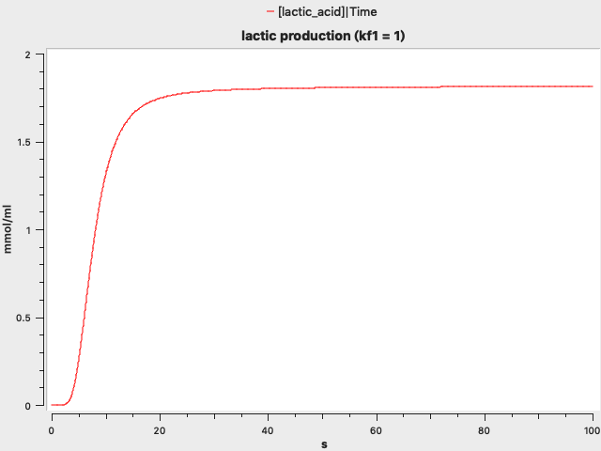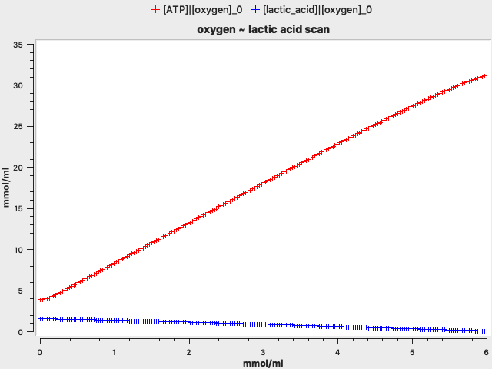

a

b

c

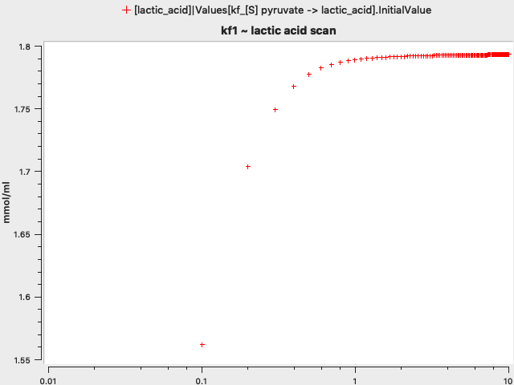

c

**The Cori cycle during exercising**

Lactic acid retained in muscles are transported to hepatocytes and converted to glucose before going back to muscle cells. To mimic the Cori cycle happened during anaerobic exercise, oxygen concentration and k6 were set to 0; k2 and k5 were both set to 1. According to the results above, kf1 was set to 10 to simulate intense exercise. Results shown in **Fig. 7** present a peak of lactic acid in skeletal muscle cells (violet curve in panel a) shortly before the peak of glucose in hepatocytes. There was a 1.7s delay of hepatic reactions resulting from glycolysis and lactic acid transportation. The green curve in panel a represents glucose returned to skeletal muscle cells in the first circulation of the Cori cycle, which compensated 85% glycose loss after 30s.

Moreover, hormones such as adrenaline released during exercises increases cardiac output, leading to higher blood flow velocity (Joyner and Casey, 2015). This phenomenon was simulated by increased k2 and k5, which were assigned to be equal and scanned from 1 to 20. **Fig. 8** shows an inverse-proportional-like relationship between blood flow velocity and lactic acid remained after a 30s period. **Fig.8** depicts the reduced peaks of lactic acid dynamics.

**Fig.7** **Effects of the Cori cycle in muscle cells and hepatocytes.** Lactic acid peaked and then transported to hepatocytes with a 1.7s delay (violet curve in **a** and green one in **b**). Energy burden was shifted to hepatocytes for gluconeogenesis (blue curve in **b**). 85% glucose returned from hepatocytes to muscle cells in 30s (green curve in **a**).



b

a

**Events simulation: exercising process**

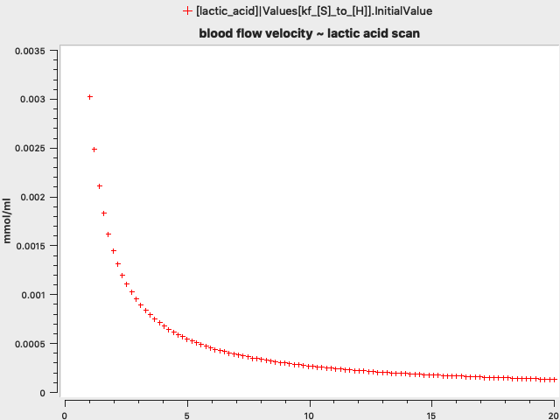

a

b

**Fig. 8 Blood flow velocity and lactic acid retention.** **a**. Inverse-proportional relationship between blood velocity and lactic acid in muscle cells. **b**. Parameter scan results shown in time course. Each curve represented lactic acid dynamics at different levels of blood flow velocity.

The whole process of rest-exercising-rest was simulated by setting events in the model. Reaction 5 had been changed to produce glucose instead of r_glucose to run the Cori cycle continuously. Initial values of glucose, oxygen, k2 and k5 were set to 4, 24, 0.1 and 0.1 respectively. At t=3, kf1 and k6 were changed to 10 and 0 respectively; k2 and k5 were both set to 1. At t=15, kf1, k6, k2 and k5 returned to 0.1, 1, 0.1 and 0.1 to mimic the rest condition.

Retention of lactic acid and much less ATP production during exercising were found in the absence of the Cori cycle (**Fig. 9 b & c**). Cori cycle slightly reduced the speed of glucose consumption in this model as shown in **Fig. 9 a**.

**Fig. 9 Rest-exercise process involving the Cori cycle.** **a.** Slightly slower consumption speed of glucose with Cori cycle involved (red arrow). **b**. Lactic acid relieved through Cori cycle; more ATP production was shown (red curve). **c**. Lactic acid retention was induced by exercising with Cori cycle blocked; less ATP production was shown (red curve).

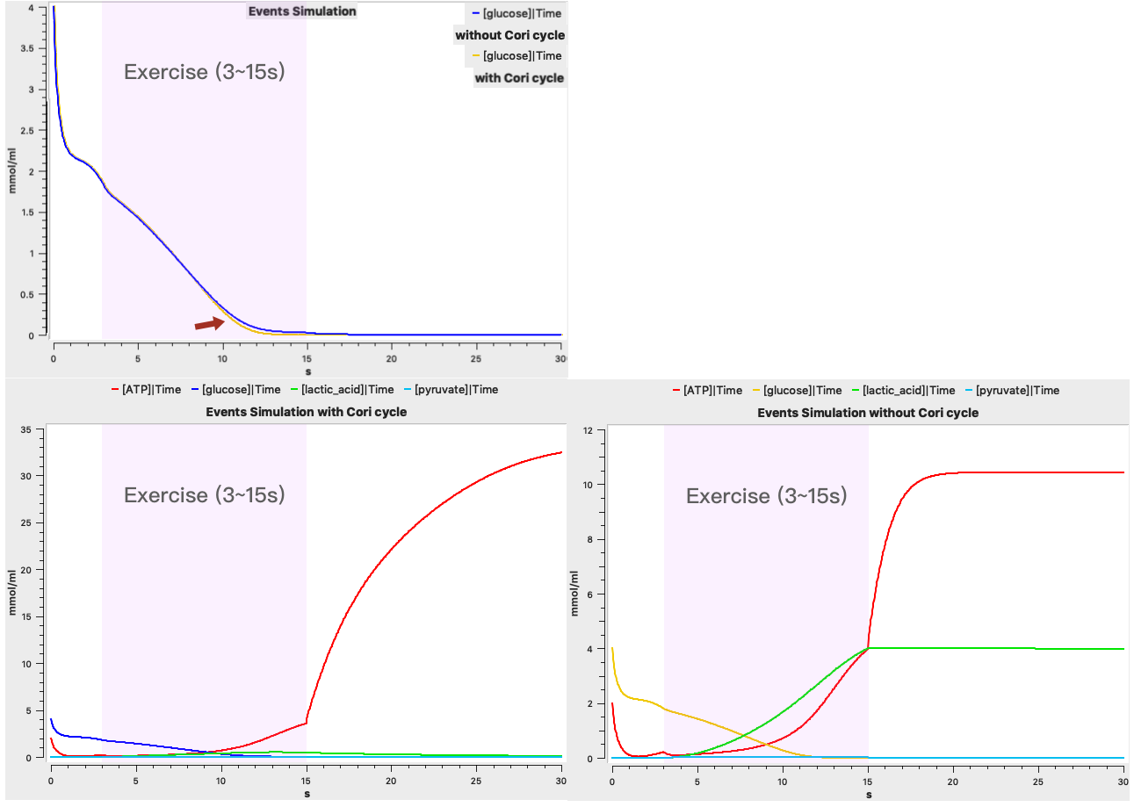

a

b

c

**Conclusions**

Through plotting in COPASI, in glycolysis, one glucose molecule is converted into two molecules of pyruvate with a net gain of 2 ATP. Plots from models with changed parameters substantiate that triose phosphate isomerase mutation negatively impacts glycolysis, which can be indicated from the pyruvate production.

Lactic acid metabolism is crucial to homeostasis. In anaerobic respiration during intense exercising, the Cori cycle removes excessive lactic acid, shifts the energy burden to hepatocytes and maintains ATP synthesis through fuelling glycolysis with recycled glucose. Such process guarantees sufficient energy source for the higher-priority muscle tissue anaerobic respiration and promotes efficient waste recycling.

**Discussion**

In the stoichiometry section, at the beginning, it was believed that at the end of glycolysis, the reaction ratio of glucose to pyruvate is always 1:2. Later, after we ran the model, we found out that the reaction ratio was actually slightly larger than 1:2. In consideration of the existence of intermediate products, glucose cannot be converted into pyruvate within one reaction. Thus, we realized that we had a little misinterpretation in the results. However, the influence on the whole tendency that 1 molecule of glucose converts to 2 molecules of pyruvate is very small.

To simulate the mutated enzyme, it was first designed to change the rate constant k, but the data set obtained was so large that it was difficult to process and show the results as well as the tendency. Later, the "parameter scan" in COPASI was used for mapping, hence successfully showed the relationship between the amount of enzyme and the final yield of pyruvate.

For the addition section, in the first place, we considered to simulate gluconeogenesis in the liver which resembles the reverse reaction of glycolysis. After thinking twice, however, we noticed that there are so many substances involve in this pathway, such as amino acids and glycerol, that it is too complex to quantify and make a model. Thus, we turned into glycogen in muscle cells that only originate from glucose. During exercise, glycogen is degraded into glucose and undergoes anaerobic respiration. But how the product, lactate, is reduced remained a question. To solve the puzzle, we did more research and found the Cori cycle. We decided to model the Cori cycle due to its importance.

Teamwork had been achieved throughout our cooperation on accomplishing this project. During our first meeting, we decided to divide the group project into several parts. Each group member was assigned with a specific section and was required to write their findings and complete that part of the report on schedule. The final report was done by merging our works together. This practice had enabled each of us to focus on one particular topic and complete our report with higher efficacy. However, disadvantages emerged in the latter part of our progression, when each of us tried hard understanding other group members’ work.

It was pleasing that our team managed to raise up conclusions and solutions during each meeting. We presented high productivity by completing each goal within allocated time. Nevertheless, there is still improvements can be made. For instance, each team member should explain their findings and conclusions of their allocated part of the project in detail before the meeting begins.

As for the improvement of the glycolysis model, more precise parameters can be assigned rather than fixed to 1 and 0.01, thus making it more interpretable by actual physiology pathways. For example, the third step of glycolysis is the determinative one and the enzyme (phosphofructokinase) involved is mediated by ATP and AMP concentration in the cytosol. Another important drawback is that the supply of metabolites, such as ATP, is taken as sufficient initial concentrations. The setting has significant effects on reaction rates when simulating large-quantity reactions because they use the mass action rate law. Simulations made here are for the observation over a certain time period of physiological processes. Therefore, it would be more reasonable to use constant flux to avoid such effects with parameters elaborately set.

**References**

ALBERTS, B., JOHNSON, A., LEWIS, J., MORGAN, D., RAFF, M., ROBERTS, K. & WALTER, P. (2015). *Molecular Biology of The Cell*. 6th ed. United Kingdom: Garland Science, Taylor & Francis Group.

BERG, J. M., TYMOCZKO, J. L. & STRYER, L. (2002). *Biochemistry*. 5th ed. New York: W H Freeman.

CAMPBELL, N. A., URRY, L. A., CAIN, M. L., WASSERMAN, S. A., MINORSKY, P. V., REECE, J. B. (2018). *Biology: A Global Approach.* 11th ed. England: Pearson Education Limited.

GUO, X., LI, H., XU, H., WOO, S., DONG, H., LU, F., LANGE, A. J. & WU, C. (2012). Glycolysis in the control of blood glucose homeostasis. *Acta Pharmaceutica Sinica B. Elsevier.* 2(4), pp358–367.

HOCHACHKA, P. & MOMMSEN, T. (1983) Protons and anaerobiosis. *Science*, 219(4591), pp1391–1397.

JOYNER, M. J. & CASEY, D. P. (2015) Regulation of Increased Blood Flow (Hyperemia) to Muscles During Exercise: A Hierarchy of Competing Physiological Needs. *Physiological Reviews*, 95(2), pp549–601.

JUEL, C. & HALESTRAP, A. P. (1999) Lactate transport in skeletal muscle - role and regulation of the monocarboxylate transporter. *The Journal of Physiology*, 517(3), 633–642.

LI, X., GU, J. & ZHOU, Q. (2015). Review of aerobic glycolysis and its key enzymes - new targets for lung cancer therapy. *Thoracic Cancer*. 6(1), pp17–24.

LIBERTI, M. V. & LOCASALE, J. W. (2016) The Warburg Effect: How Does it Benefit Cancer Cells? *Trends in Biochemical Sciences*, 41(3), pp211–218.

ROBERGS, R. A., GHIASVAND, F. & PARKER, D. (2004) Biochemistry of exercise-induced metabolic acidosis. *American Journal of Physiology-Regulatory, Integrative and Comparative Physiology*, 287(3), R502–R516.

YUAN, X. & BRAUN, T. (2017) Multimodal Regulation of Cardiac Myocyte Proliferation. *Circulation research,* 121(3), pp293–309.